# Bug Summary Report – OpenCart Demo Site

## BUG-1 - Product option dropdown is not functional on the Canon EOS 5D details page

**Description**: The product option dropdown on the Canon EOS 5D details page does not display selectable options, preventing users from configuring the product and adding it to their cart.

**Steps to Reproduce:**  
1. Launch <https://demo.opencart.com/> url  
2. Enter “Canon EOS 5D” in the search bar and search for the product  
3. Navigate to “Canon EOS 5D” product details page  
4. Try to select a value from the “**Available options”** dropdown  
5. Observe that the dropdown list is empty and no options are coming for selection

**Actual Result**: The “**Available Options”** dropdown on the Canon EOS 5D product details page does not display any selectable values. As a result, the user is unable to configure the product and is blocked from proceeding with adding it to the cart

**Expected Result**: The “**Available Options”** dropdown should display all valid selectable values (e.g., size, color, configuration). The user should be able to choose an option successfully and continue to add the product to the cart without any restriction

**Evidence**:

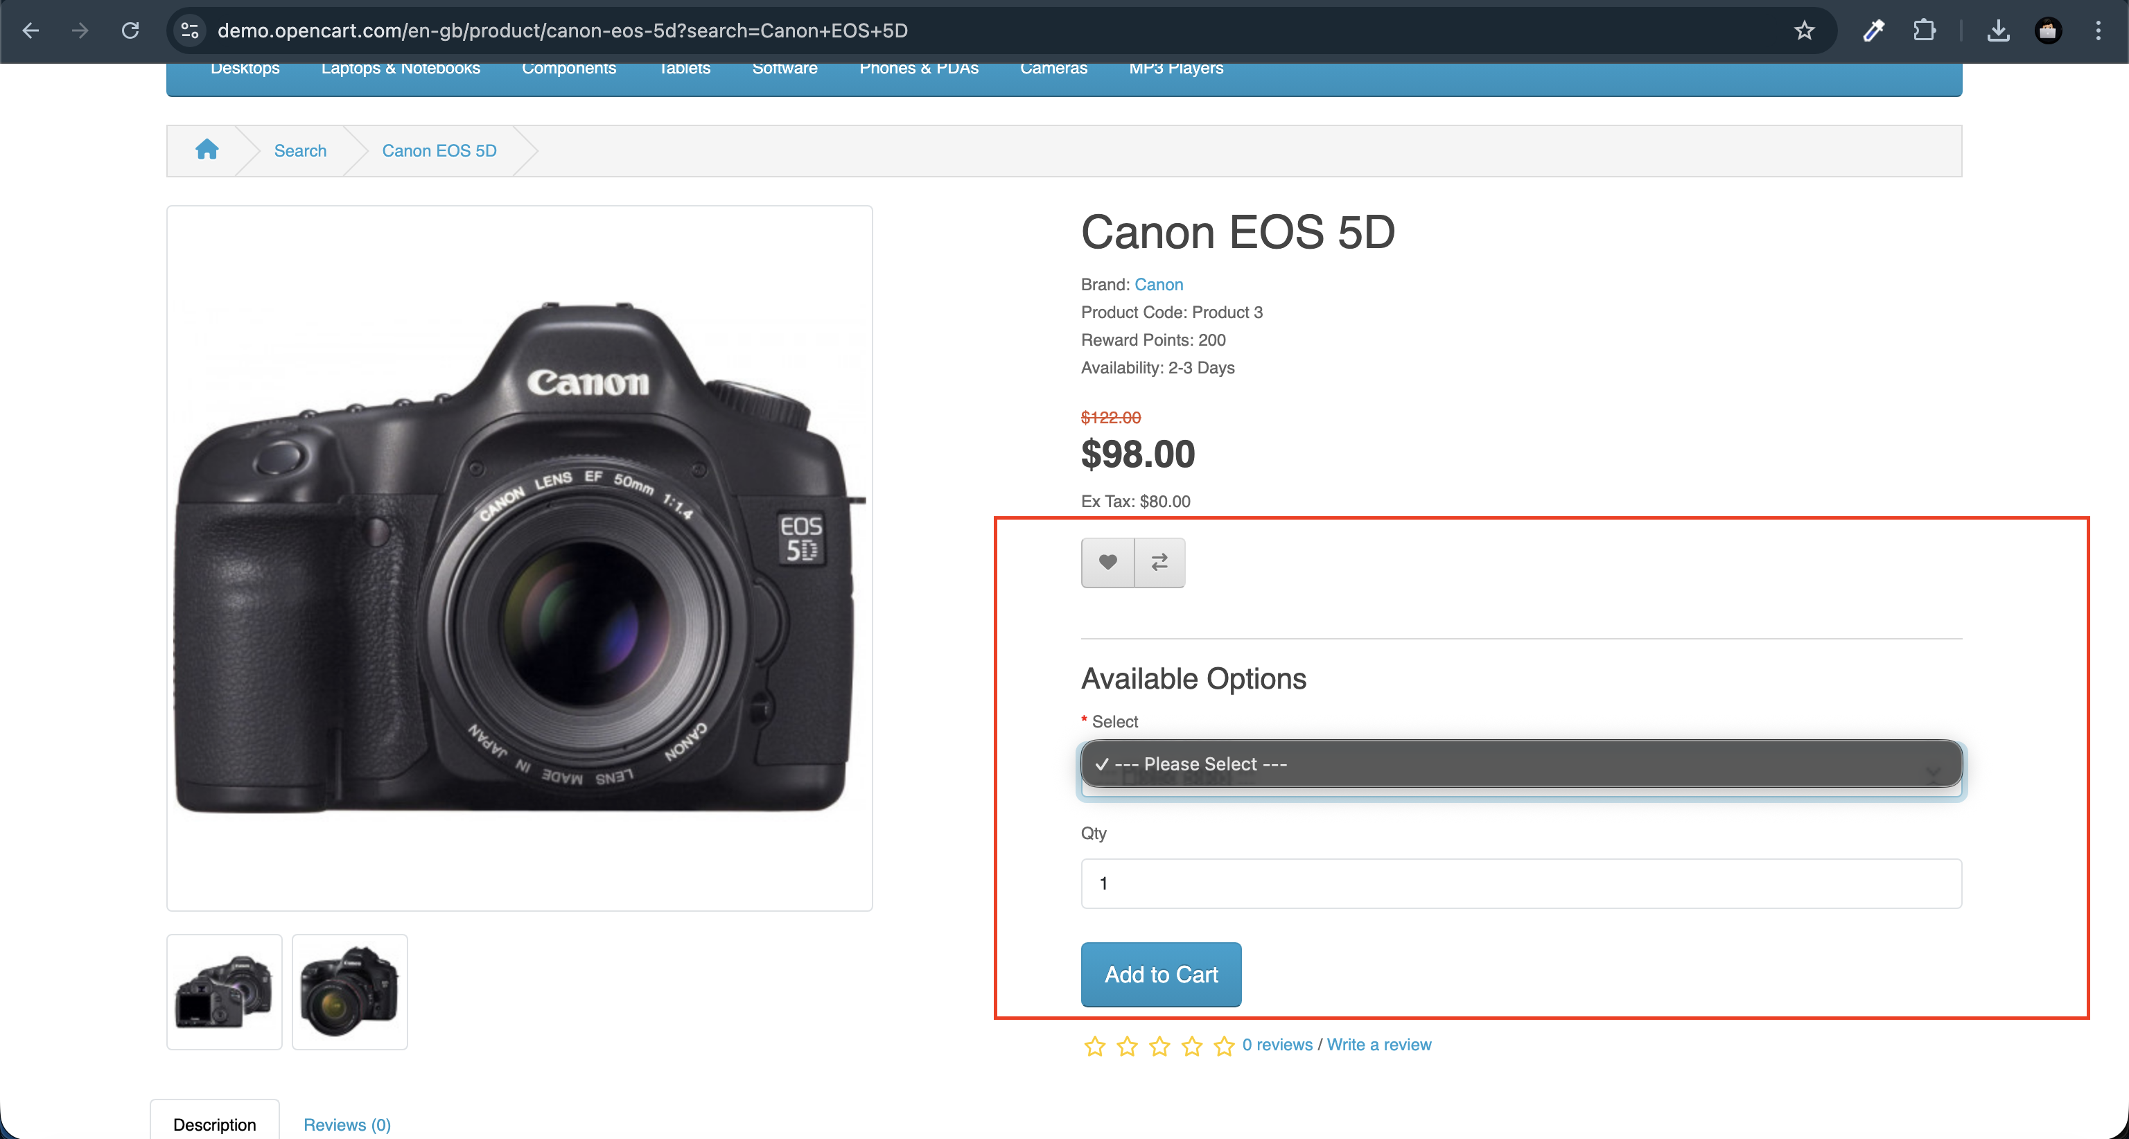

## BUG-2 – User is allowed to add out-of-stock products and later shows “invalid product quantity” error on shopping cart page

**Description**: User is allowed to add out-of-stock products without warning, but later displays an “invalid product quantity” error on the cart page. This misleads users and disrupts the purchase flow.

**Steps to Reproduce**:  
1. Launch <https://demo.opencart.com/> url  
2. Add the “**iPhone**” product to the shopping cart  
3. Navigate to the shopping cart page  
4. Observe that added product is marked as unavailable in stock

**Actual Result:**  
When the user adds the iPhone product to the cart and navigates to the shopping cart page, an error message appears stating “Products marked with *** are not available in the desired quantity or not in stock.” This indicates that the item cannot be purchased despite being added to the cart.

**Expected Result:**  
Products that are not in stock should not be available for selection or addition to the cart. Only in-stock items should be visible and purchasable to ensure a consistent and reliable shopping experience.

**Evidence**:

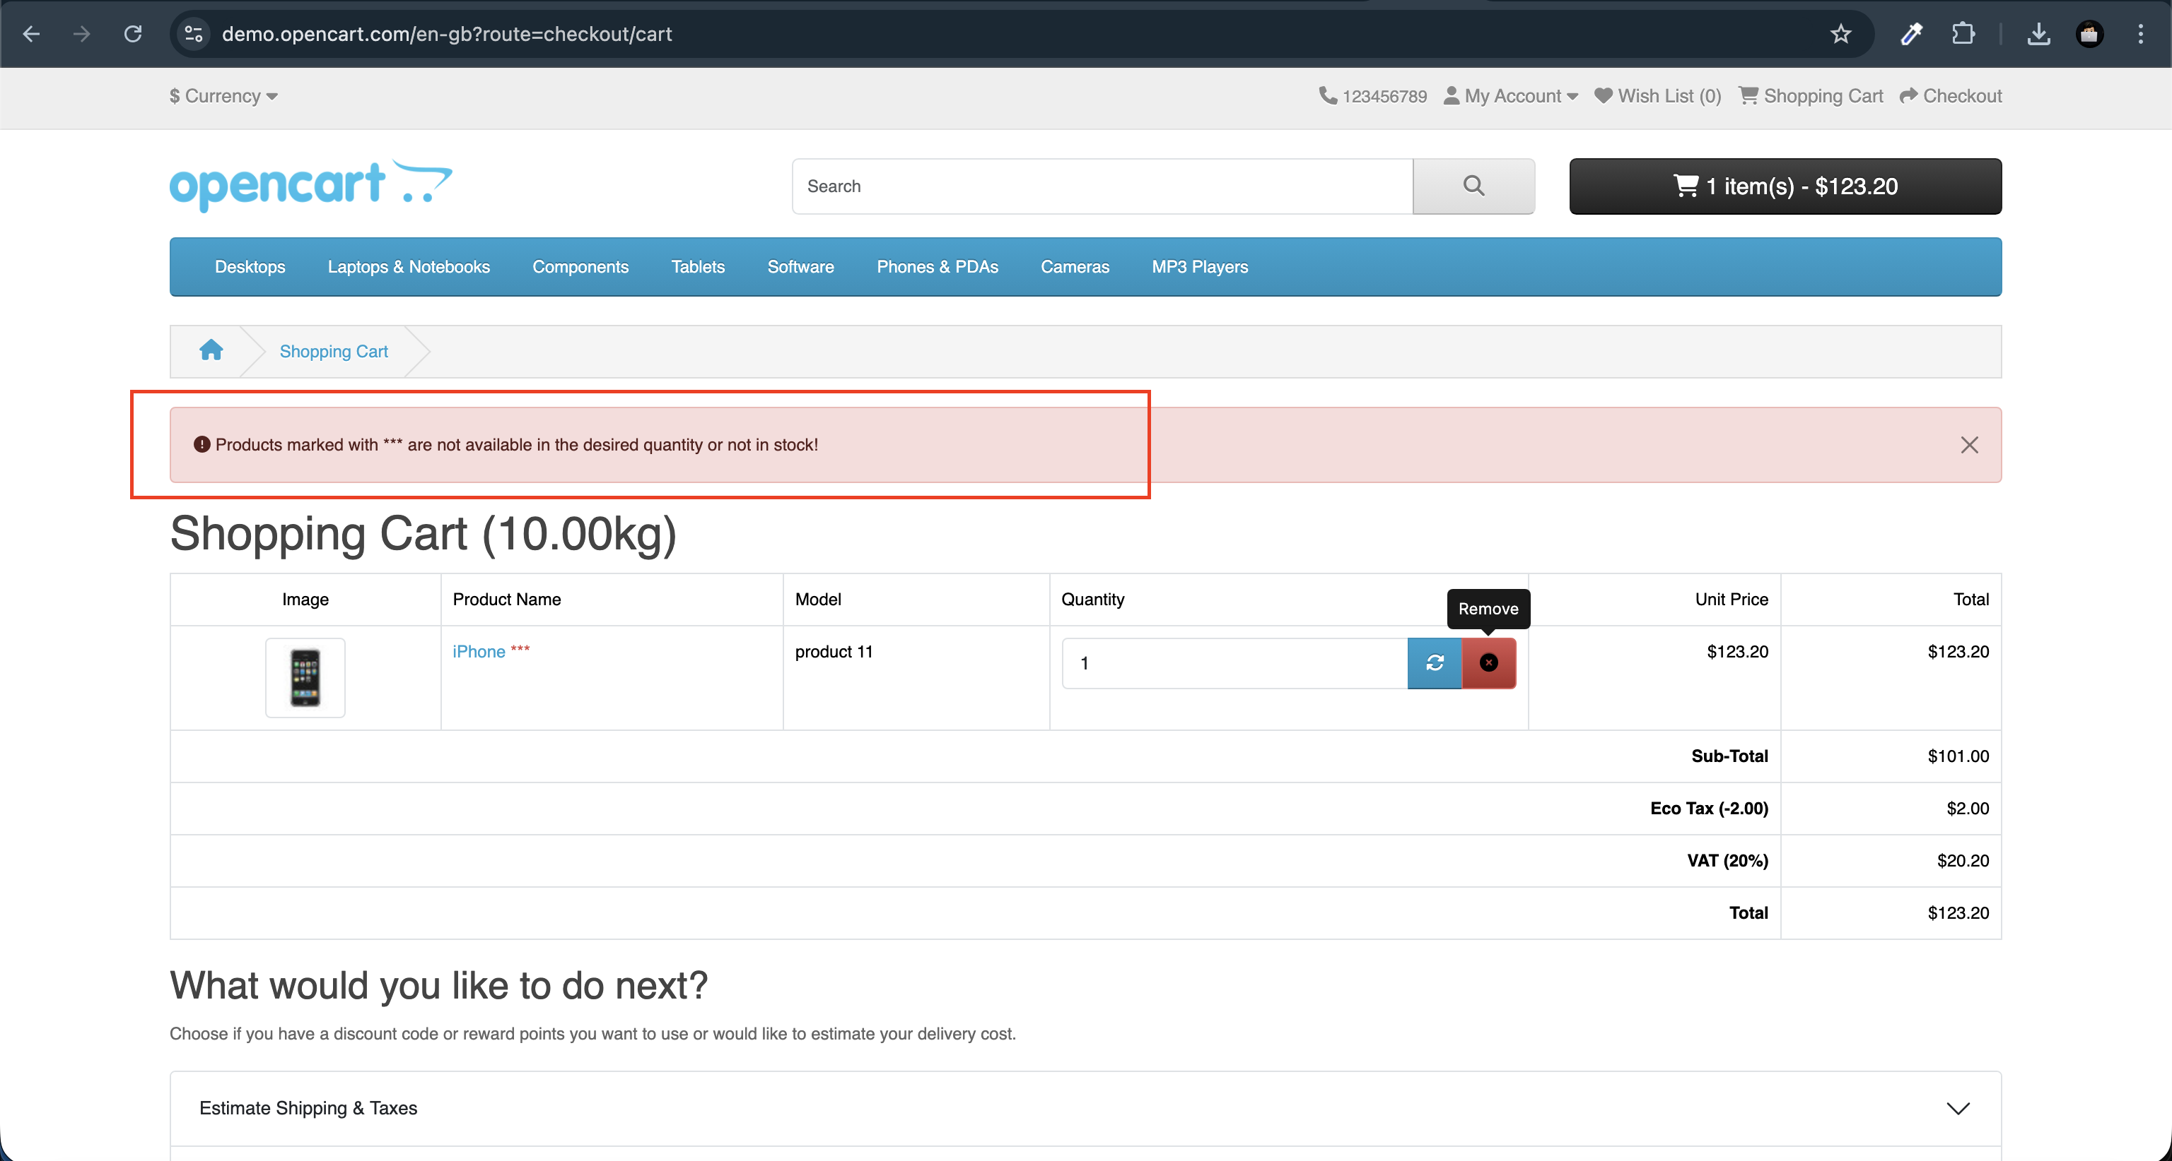

## BUG-3 - Home page banner tiles do not navigate to the correct product pages — the iPhone banner redirects to the Camera page, and the MacBook banner does not open any page

**Description**: On the home page, the rotating product banner displays promotional tiles for featured products such as iPhone and MacBook. However, when a user clicks on the iPhone banner, it incorrectly redirects to the Camera category page instead of the iPhone product page. Similarly, clicking the MacBook banner does not trigger any navigation, leaving the user stuck on the same page. This results in broken navigation and inconsistent user experience.

**Steps to Reproduce**:  
1. Launch <https://demo.opencart.com/> url  
2. On the home page, observe the rotating product banner  
3. Wait for the “**iphone”** tile to appear and clicking on it redirects user to the camera page  
4. Wait for the “**MacBook”** tile to appear and clicking on it does not open any page. **5.** Observe that the banner tiles do not navigate to the correct product pages

**Actual Result:**  
When interacting with the rotating product banner on the home page, the iPhone tile redirects to the Camera page, and the MacBook tile does not open any page. The banner tiles fail to navigate to the correct product details.

**Expected Result:**  
Each banner tile should correctly navigate to its respective product details page. For example, clicking the iPhone tile should open the iPhone product page, and clicking the MacBook tile should open the MacBook product page.

**Evidence**:   
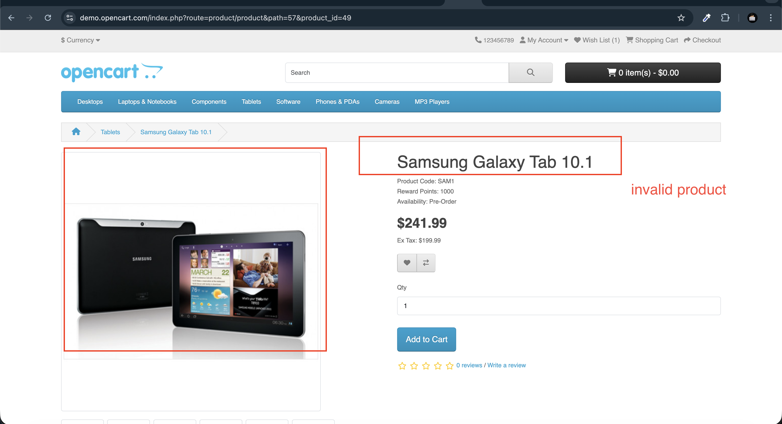

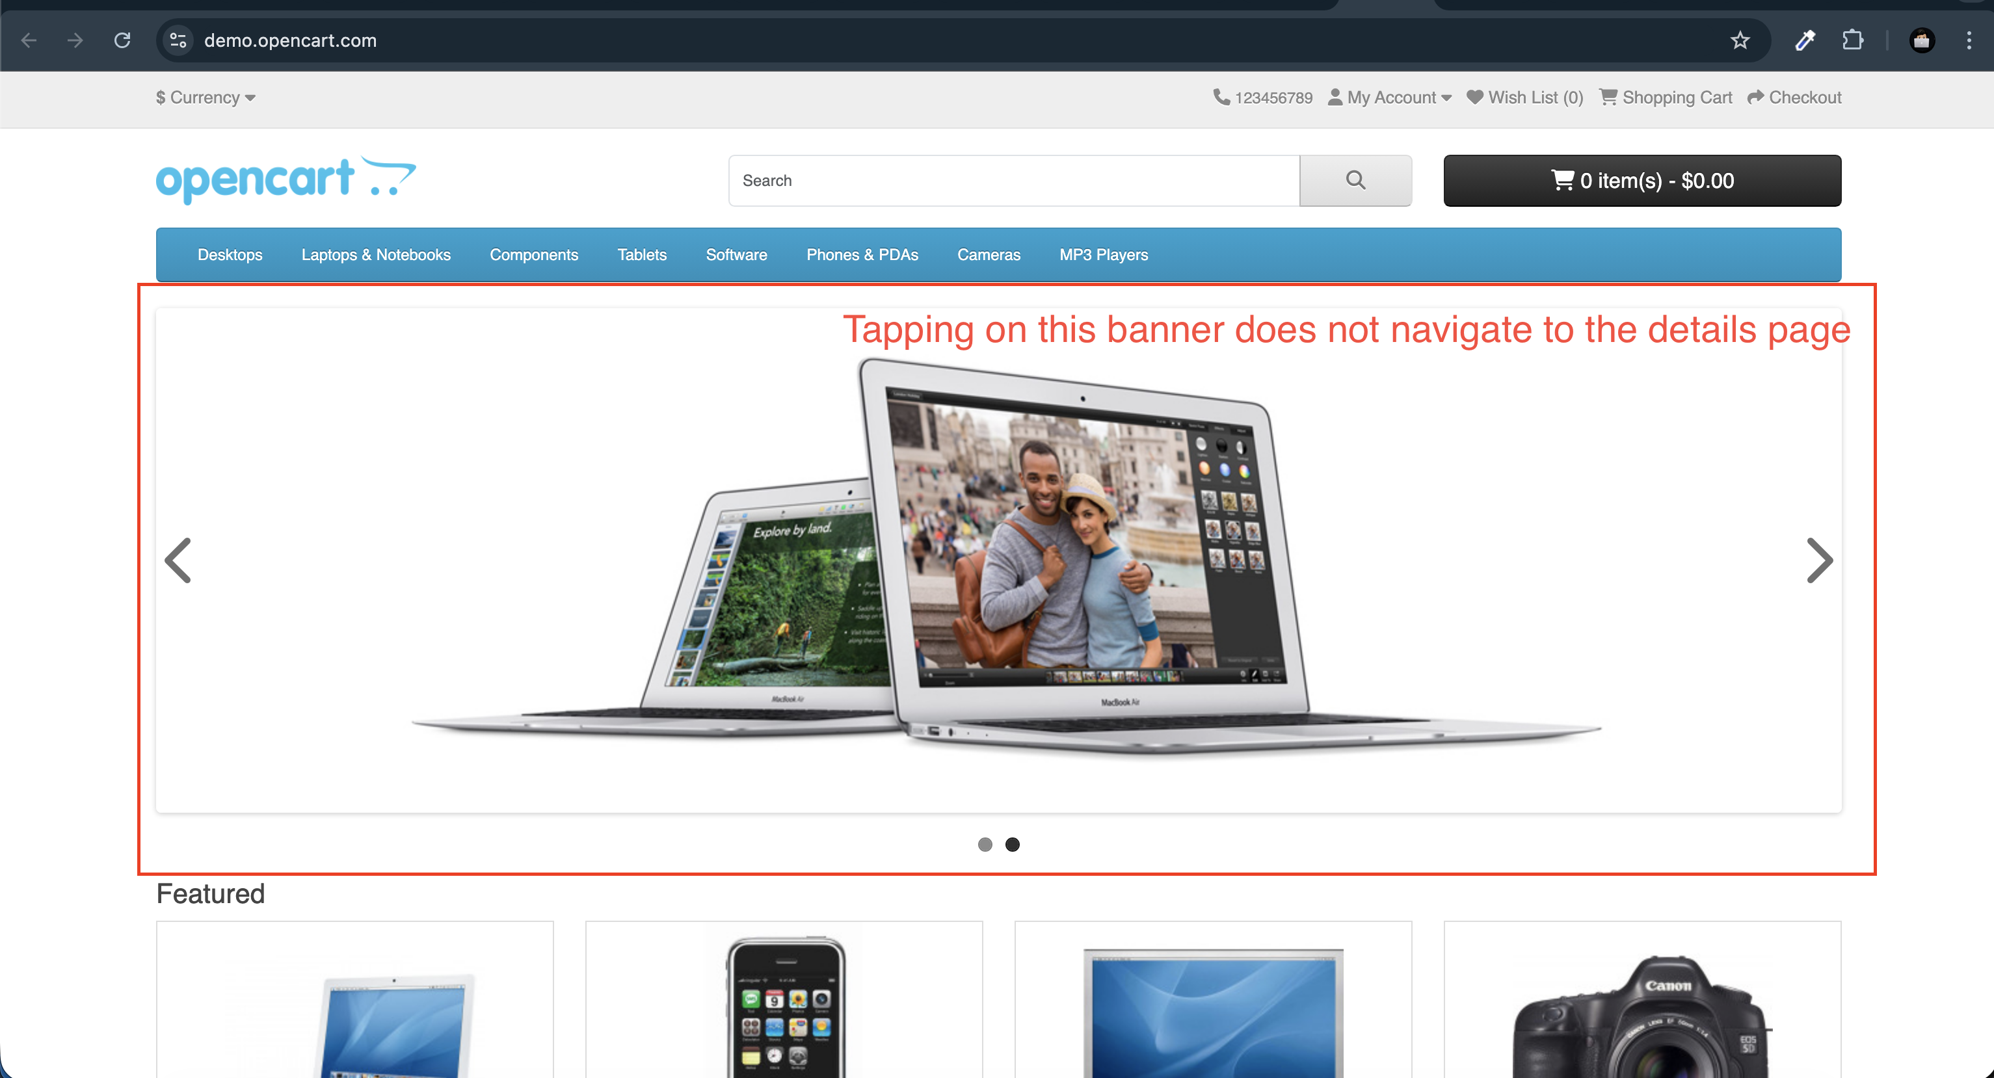

## BUG-4 - Invalid test products are displayed in the MP3 Player hover menu instead of showing the actual available products

**Description**: Hovering over the MP3 Player menu shows invalid test products with quantity “0.” This misleads users into thinking no items are available. However, the MP3 Player category page lists four valid products, causing inconsistency.

**Steps to Reproduce**:  
1. Launch <https://demo.opencart.com/> url  
2. Hover over the “**MP3 Player menu**”  
3. Observe test products with count “0” are displayed  
4. Click on show All MP3 players  
5. Observe that details page lists 4 valid products, which are not shown in the hover menu.

**Actual Result:**  
The MP3 Player hover menu displays invalid test products with quantity “0,” while the actual available products are hidden.

**Expected Result:**  
The hover menu should display the same valid products as listed on the MP3 Player category page, ensuring consistency.

**Evidence**:

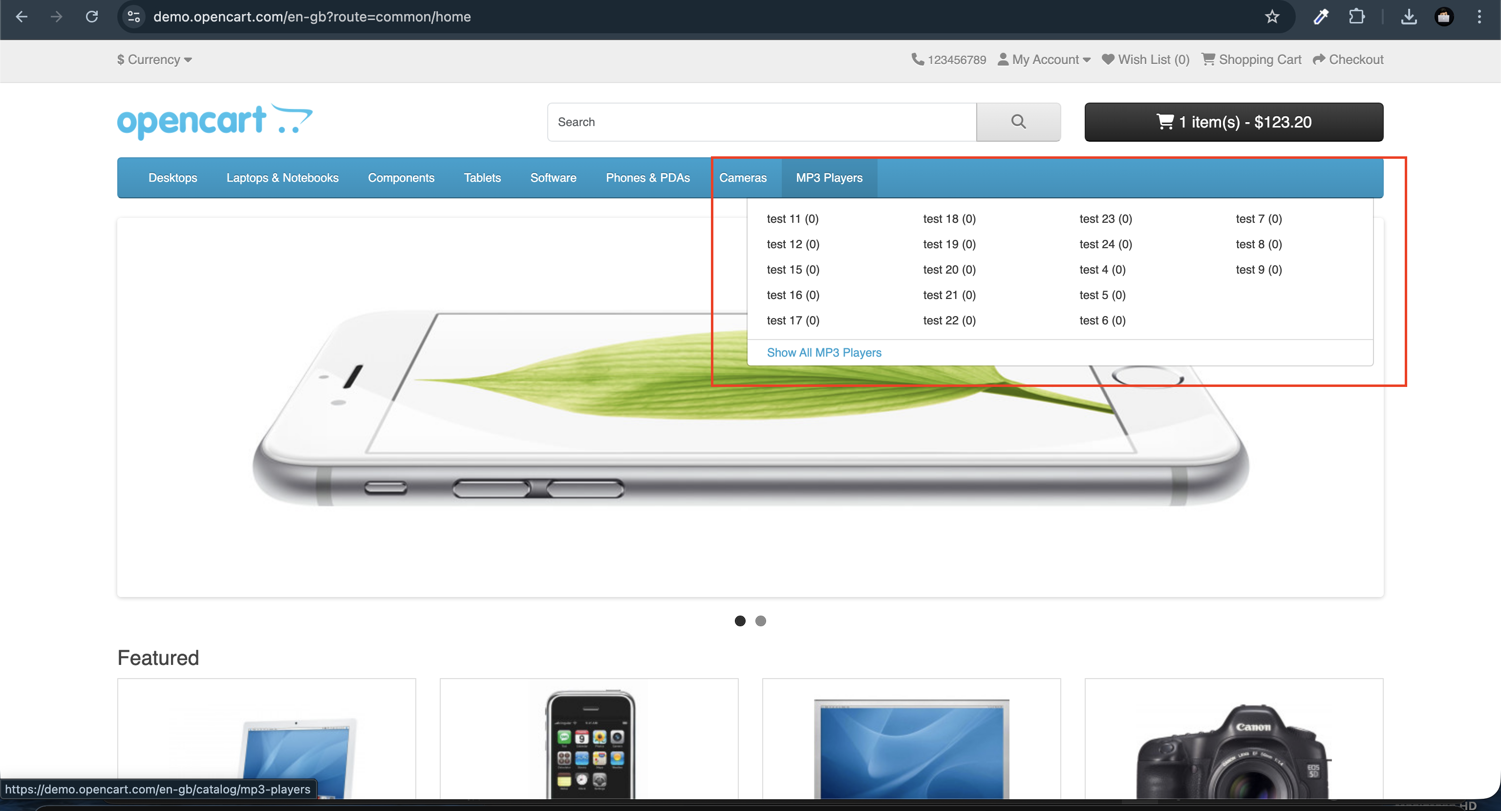

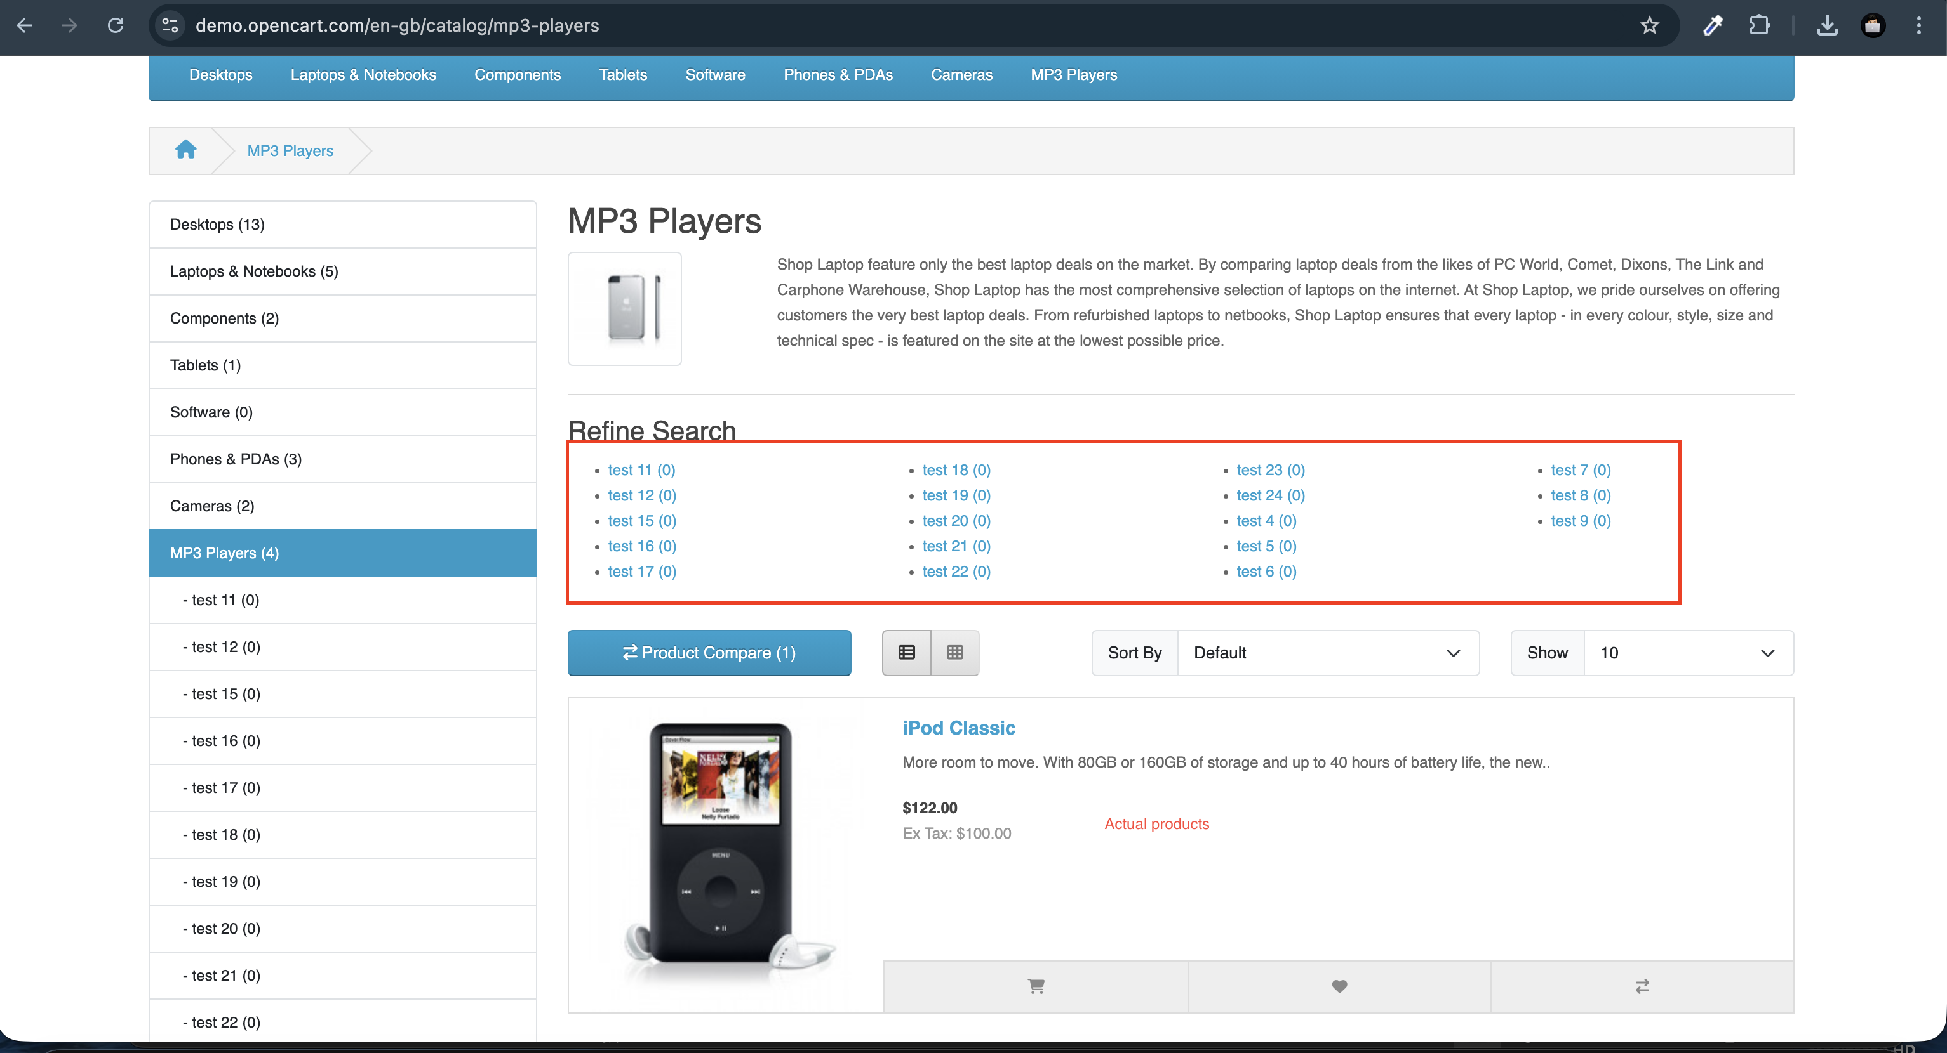

## BUG-5 - Write a Review functionality is broken — submit action does not process the review

**Description**: When a user tries to add a review on the product details page and clicks the **Submit** button, nothing happens. The review is not processed or displayed, leaving the functionality incomplete.

**Steps to Reproduce**:  
1. Launch <https://demo.opencart.com/> url  
2. Navigate to “**iphone”** product details page by searching it  
3. Click on **Write a Review** and fill the required fields  
4. Click the submit button  
5. Observe that review does not get submitted

**Actual Result:**  
After filling the Write a Review form and clicking **Submit**, nothing happens. The review is not saved or displayed on the product page.

**Expected Result:**  
On clicking **Submit**, the review should be successfully submitted, saved, and displayed under the product reviews section

**Evidence**:

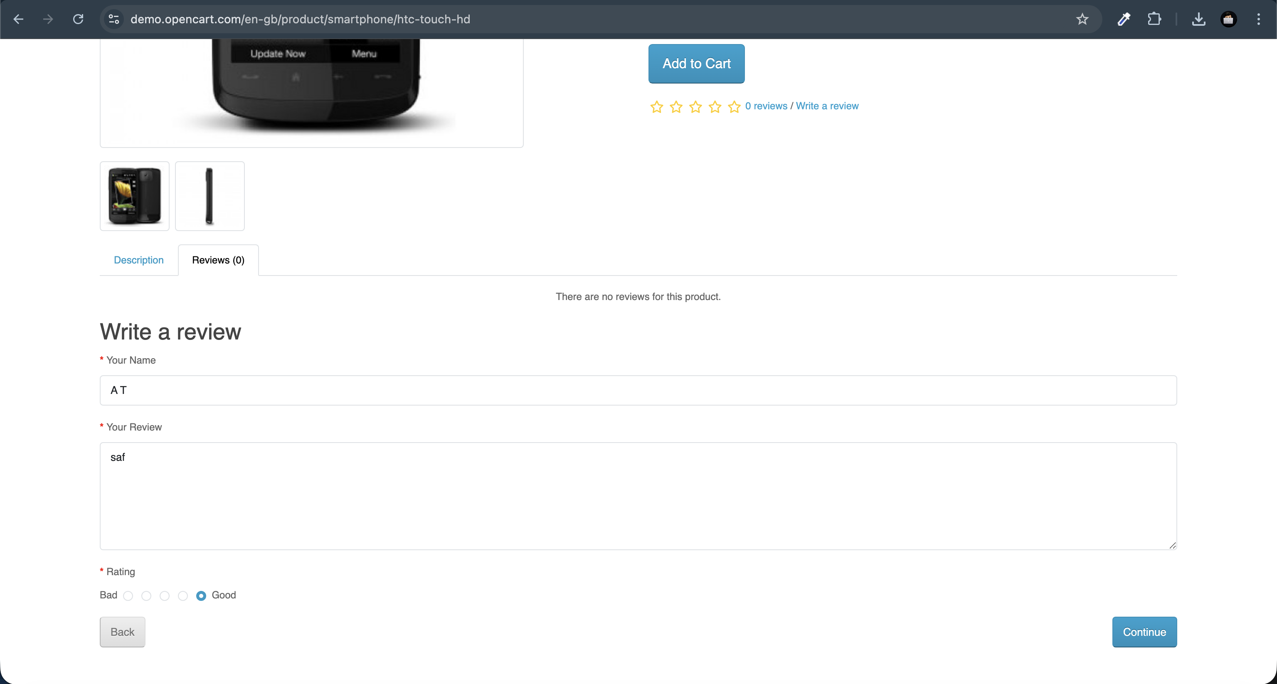

## BUG-6 - Name validation is inconsistent — registration allows a 2-character name, but the enquiry form enforces a 3-character minimum, even when the name is auto-filled

**Description**: During registration, users can create an account with a first and last name containing only one character each. However, when submitting an enquiry through the Contact Us form, the same auto-filled name is rejected with a validation rule requiring at least three characters. This inconsistency leads to a poor user experience and prevents genuine enquiries from being submitted.

**Steps to Reproduce**:  
1. Launch <https://demo.opencart.com/> url  
2. Register an account with a 2 character name (e.g. first name=A, last name = T)  
3. Go to the contact us form by navigating to My account   
4. Leave auto-filled first and last name as it as and enter description  
5. Click on the submit button  
6. Observe that the form rejects the input, showing a validation error requiring a minimum of 3 characters

**Actual Result:**  
The Contact Us form rejects the auto-filled 2-character name (e.g., “AT”) with a validation error requiring at least 3 characters.

**Expected Result:**  
The validation rules should be consistent. If a 2-character name is allowed during registration, it should also be accepted in the enquiry form, or both forms should enforce the same minimum character rule.

**Evidence**:

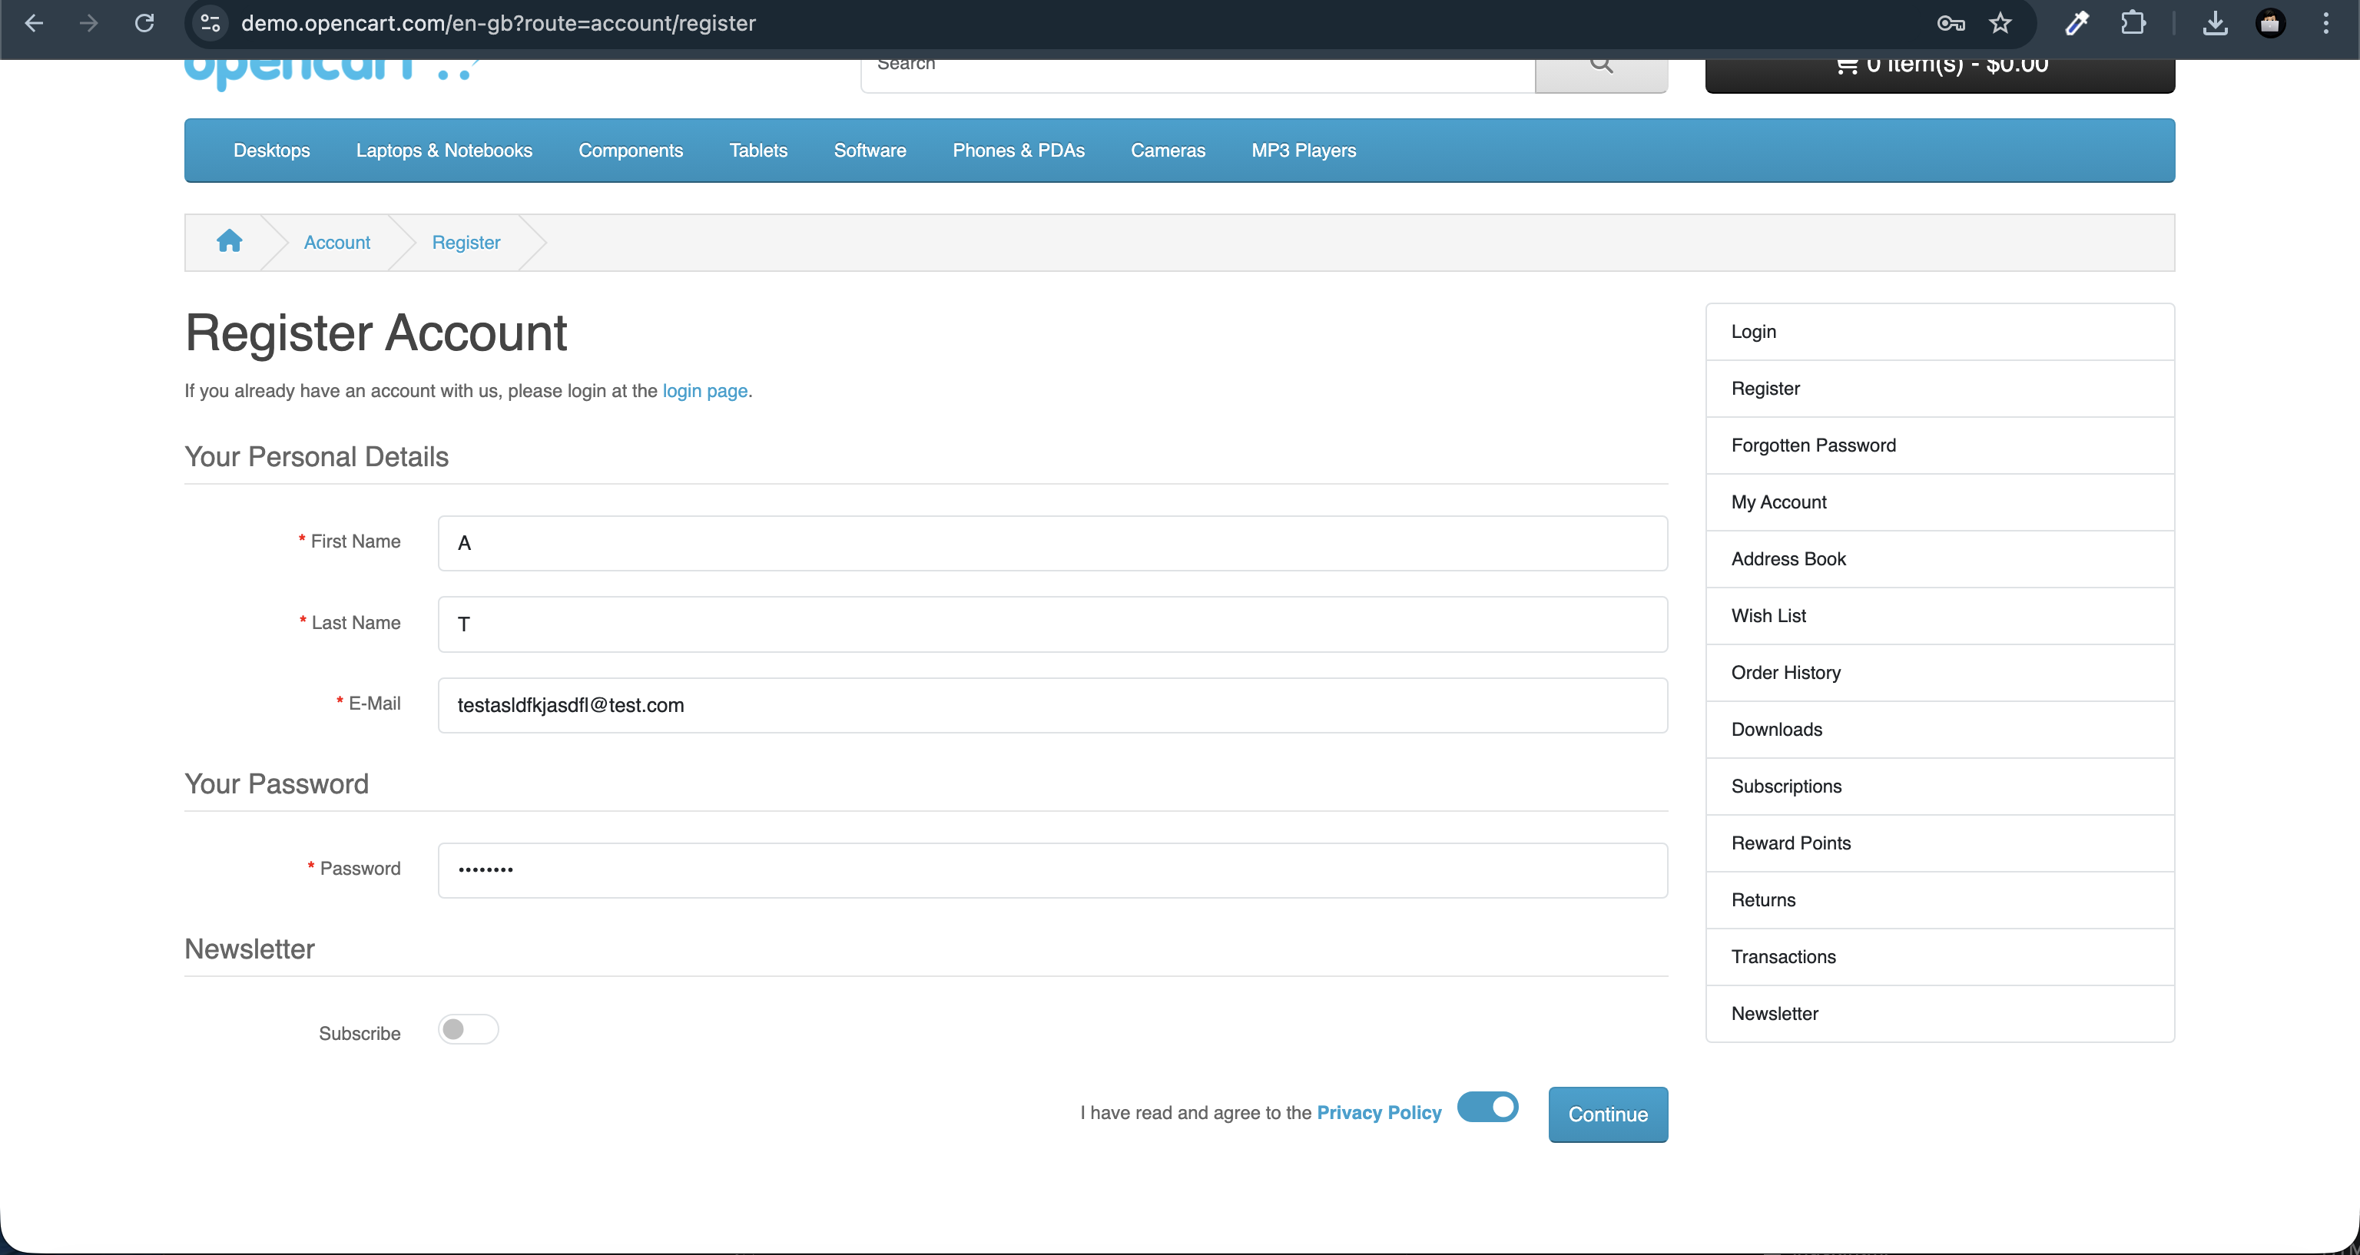

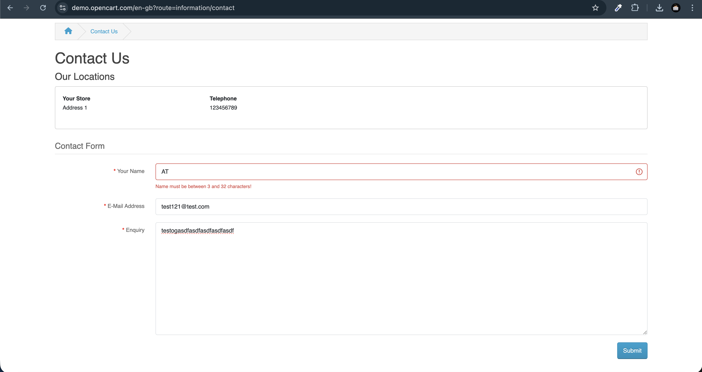

## BUG-7 - Shopping Cart and Checkout links both redirect to the same page, causing confusion in the purchase flow.

**Description**: Clicking on both the Shopping Cart and Checkout links from the top navigation redirects the user to the same page. This creates confusion, as users expect the Shopping Cart to show items for review and Checkout to guide them through the purchase process.

**Steps to Reproduce:**1. Launch <https://demo.opencart.com> url  
2. Click on the “**shopping cart”** link in the top navigation  
3. Observe the displayed page and then click on checkout link  
3. Now observe both link redirects to the same page

**Actual Result:**  
Both Shopping Cart and Checkout links navigate to the same page, offering no distinct checkout flow.

**Expected Result:**  
The Shopping Cart link should display items added to the cart, while the Checkout link should guide users through the order placement process.

**Evidence**:   
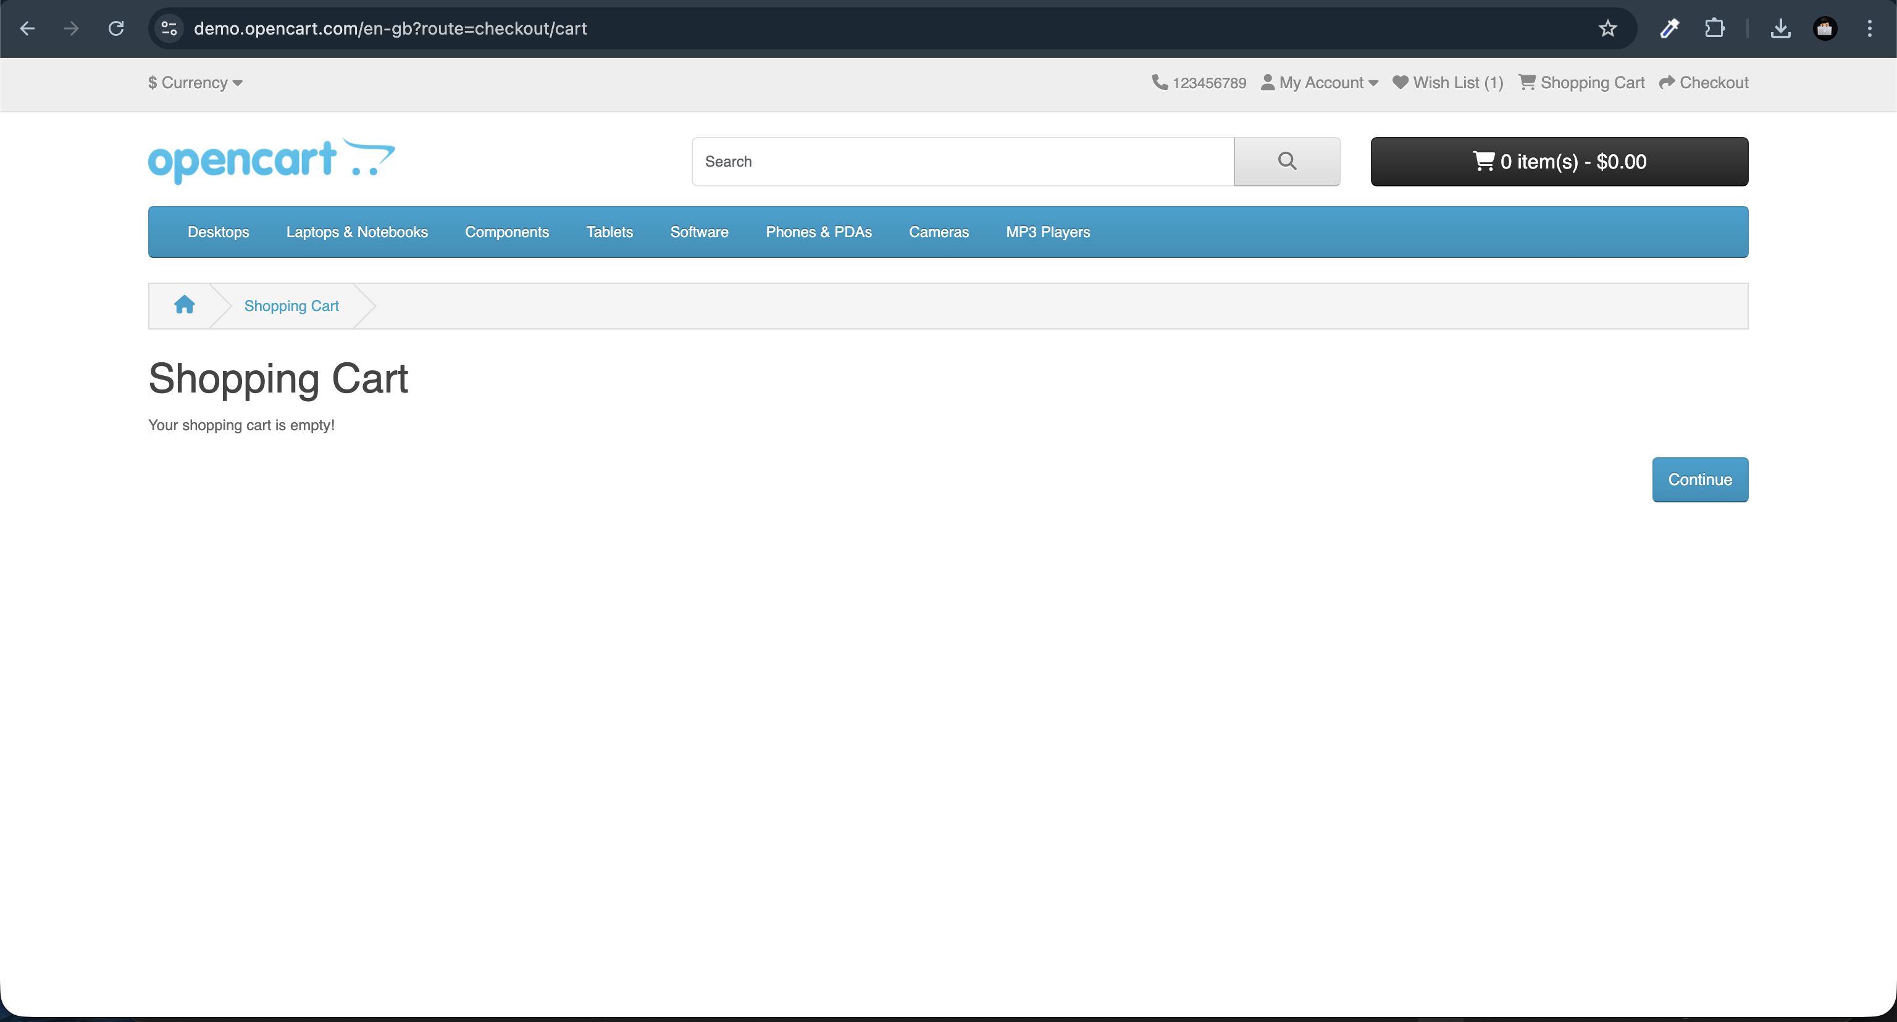

## BUG-8 - Product details page shows incorrect images in the gallery that do not match the selected product Description: On certain product details pages, the image gallery displays pictures that do not correspond to the selected product. This creates inconsistency between the product being viewed and the images shown, leading to confusion and mistrust for users

**Steps to Reproduce:**  
1. Launch <https://demo.opencart.com>  
2. Search the “**Apple Cinema”** in the search bar  
3. Navigate to the **Apple Cinema** product details page.  
4. Open the product image gallery.  
5. Observe that the gallery displays incorrect images that do not match the product.

**Actual Result:**  
The Apple Cinema product gallery displays unrelated camera images instead of the correct Apple Cinema product images.

**Expected Result:**  
The product gallery should display only images that correspond to the selected product (Apple Cinema).

**Evidence:**

